**Trabajo Práctico 6 - Sistemas Operativos**

**Integrantes:**

* Borgogno, Francisco
* Cañas, Felipe
* Lucero Ruiz, Maximo
* Quesada, Santiago

**Profesor:** Funes, Gustavo

**1.**

| **echo "" > /tmp/DocEmpty.txt** |
| --- |



**2.**

| **sudo cp /tmp/DocEmpty.txt ./base.txt** |
| --- |

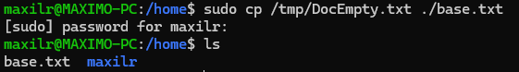

**3.**

| **sudo vim base.txt** |
| --- |



| **cat base.txt** |
| --- |

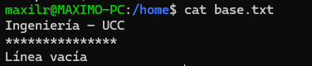

**4.**

| **cat /var/log/fontconfig.log >> base.txt** |
| --- |

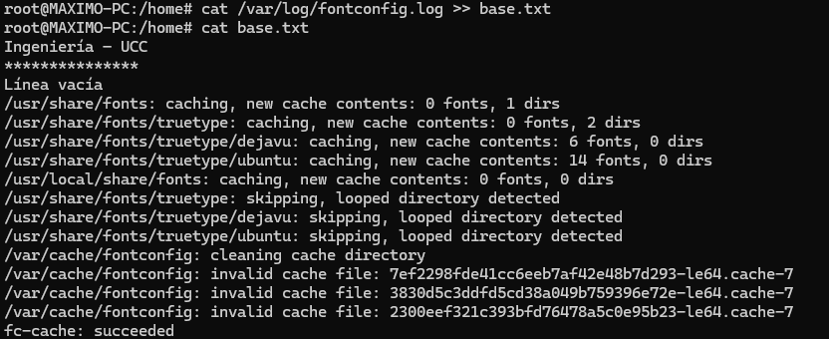

**5.**

| **less base.txt** |
| --- |

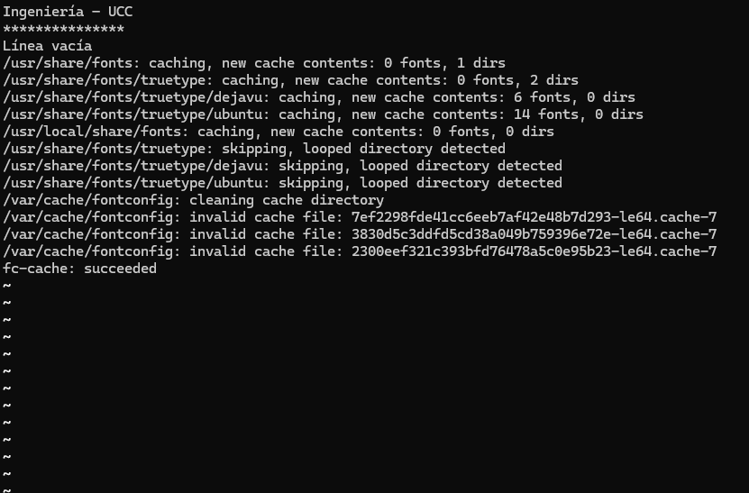

**6.**

| **sed -i "s/fonts/FONTS/g" base.txt** |
| --- |



**7.**

| **cat -n base.txt** |
| --- |

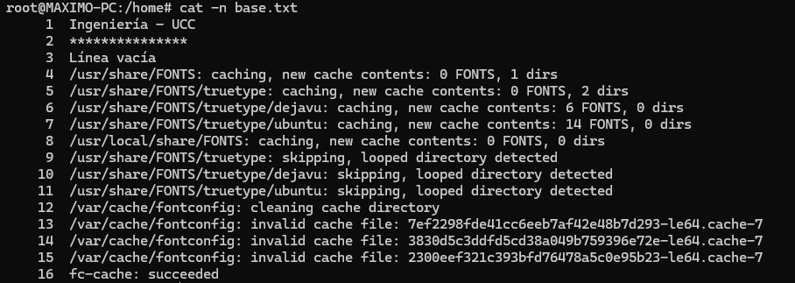

**8.**

| **seq 1 20 > numeros.txt** |
| --- |



**9.**

| **tac numeros.txt** |
| --- |

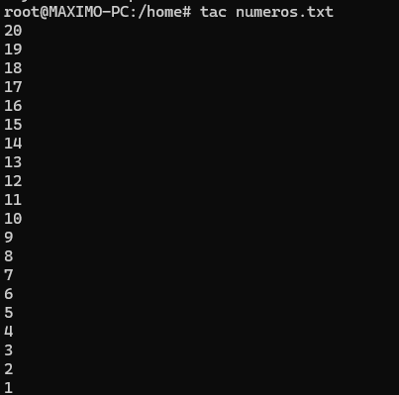

**10.**

| **head -n 5 numeros.txt** |
| --- |

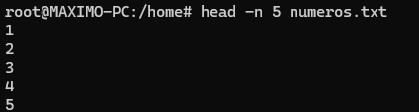

**11.**

| **tail -n 5 numeros.txt** |
| --- |

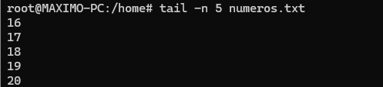

**12.**

| **cp numeros.txt numeros.bak** |
| --- |



**13.**

| **vim numeros.txt** |
| --- |

**14.**

| **diff numeros.txt numeros.bak** |
| --- |

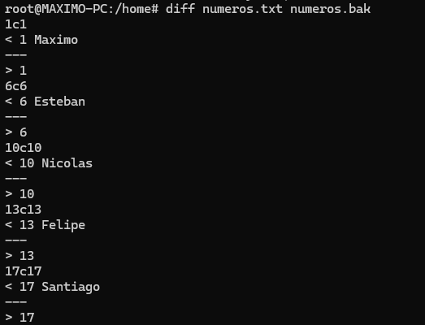

**15.**

| **zip numeros.tar numeros.txt numeros.bak** |
| --- |

